A Report
Of
Third Women’s Tribunal against Poverty

On
Single Women
30-31 August, 2010, at the
Social Development Centre, Purulia Road Ranchi,Jharkhand

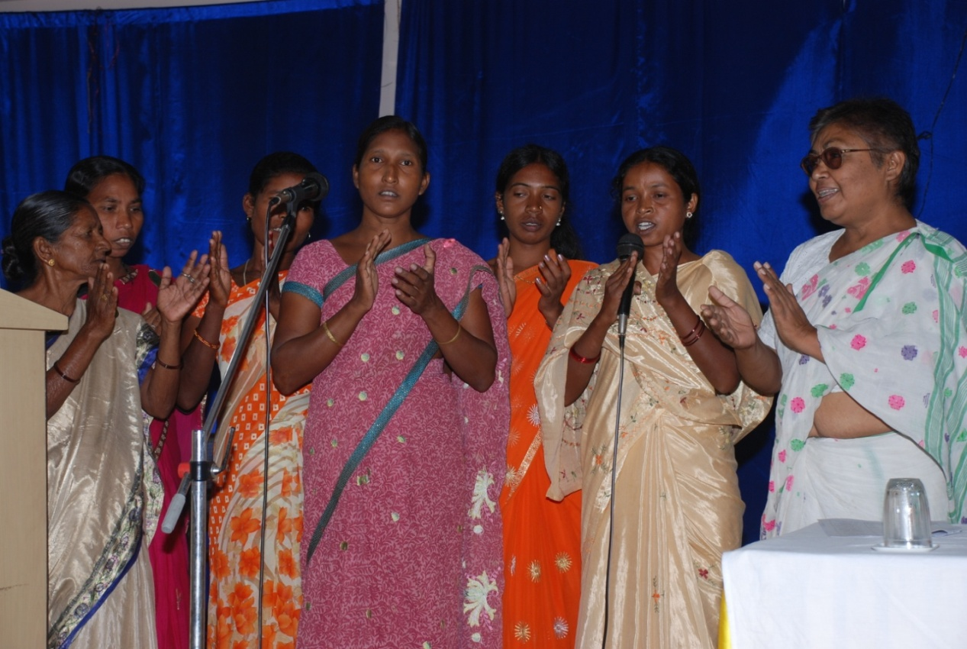

Organized By – EKAL NARI SASHAKTI SANGHATHAN

& SHRAMAJIVI MAHILA SAMITY

Collaboration with – WADA NA TODO ABHIYAN

A Report
of
Third Women’s Tribunal Against Poverty
On
Single Women
Background:-
India is a developing nation that visualizes a process of change in the quality of life of its people. Hence it is 10 years of time that it is implementing million development goals (MDG) oriented program. The achievements no doubt ate seen in terms of data and figures towards improvements but the women organizations and CSO’s point out many shortcomings in the achievements.

The second criticism on MDG is that it is all oriented towards quantitative targets while the change in figures and data should get reflected on improvements in quality of life. In order to understand how the achievements on MDG are getting translated into improving quality of life, we need to hear women’s voice.

With this objective in mind’ Wada Na Todo Abhiyan’ a campaigning body has planned to hold women’s Tribunal in 10 states throughout the country. One of such women’s Ekal Nari Sashakti Sangathan a Jamshedpur based women organization in Jharkhand and Wada Na Todo Abhiyan on 3oth & 31st August 2010.

Introduction:-
Ekal Nari Sashakti Sangathan a single women based organization for the last 3 years works for the single women and their multifarious issues and problems. The organization is a national level organization and the state level organisation is headed by two directors, Ms. Purabi Paul and MS. Binny.

Hence the collaboration of Ekal Nari Sashakti Sangathan and Wada Na Todo Abhiyan organization a two days women tribunal on 30th & 31st August 2010 at Social Development Centre, Purulia Road, Ranchi. This was the third women’s tribunal held in the state of Jharkhand amidst many such tribunals to be held in due course across India in 10 states. It is the women’s voice against poverty, exclusion, deprivation disparities and discrimination, gender biasness and inequalities faced by women with special focus on single women. The state of Jharkhand is a witness to the vulnerabibty and inhumanity meted out to the single women who are also victims of being dalit, adivasi, landless, poverty struck & marginalized.

The tribunal is a brain storming wherein its report, experience & throught sharing has enable formulations to lead it to the national level form to be held between 19th to 21st September 2010 at New Delhi. The national level programme will serve as the baseline for the United Nations organization, New York to discuss the issues of single women on a global level.
A preparatory meeting was conducted on 18-19 August 2010 at HPDC, Ranchi with women headed organization in Jharkhand. The organizing committee and ENSS representatives to chalk out the conduct of the two day women tribunal in collaboration with ENSS and WNTA at Social Development Centre, Ranchi.

The broad goals of the programme:-
- Address the inequalities of women depending on their belongingness to other social groups like class, caste, religion, social status, origin and economic status.
- Recognizing the diversity & differential needs of women, emergence of comprehensive programs for reduction of disparities is the need of the context.
- Forum to propose for the creation of opportunities for women who represent the most excluded groups (caste, religion, social status & economic status) to voice their experience in the context of million development goals.

The objectives of the tribunal:-
- To provide on opportunity to women belonging to socio-eco-politically exccluded groups to share their live experience in the contest of implementation of MDG in last years.
- Amongst all the MDG goals, prority on reduction of disparities and creation of space for their inclusive growth is a must.
- Disparities in all aspects of life social, economic and political need to be taken into consideration.
- Access to health care services a comprehensive health care service that includes maternal and infant health care services.
- Access to education- universalization of education with quality.

The aforesaid objectives shall enable for advocating rearranging priorities of the government as well as making inputs for 12th five year plan and make it truly on instrument that addresses the diverse and differential needs of women.

Inauguration:-
The two days women’s tribunal was inaugurated by its Vasavi Kiro, members of the women commission, Mr. Anil Singh, Co-ordinator of Wada Na Todo Abhiyan, Ms. Purabi Paul, Director Ekal Nari Sashakti Sangathan, Jamshedpur zone, Dr, Binni, Director, Sharc, Hazaribag and Mrs. Evanjilista Kandulna from Simdega jointly lighting the lamp and declaring the tribunal open. The eminent guests were presented green plants and welcomed followed by a welcome song.

Programme Session:-
The first day programme was divided into three sessions. The first session was a custain raiser session initiated by Shri Anil Singh- national working Committee member of Wada Na Todo Abhiyaan, he discussed the subject of the tribunal with an introduction on WNT. He stated that WNTA has formed its association in 22 states wherein two woman tribunals have already been conducted. The first tribunal was against poverty and the second dealt with different issues and cases of women. He focused on the third tribunal that would discuss issues pertaining to minorities’ adivasies and single women their education, health, land and livelihood. The recommendations herein that would come forth would be presented in the national level forum thereby represented by 7 women members from India at the global level to be conducted by United Nations Organization.
Ms. Purabi Paul: - The director ENSS was the next to address the first session. She stated that the single women programme is being run in 38 blocks of 18 districts. She lamented and asserted that the CSO’s are co-operating and supporting the govt. towards its fulfillment of objectives of MDG but the Govt. representatives make lame excuse and do not turn up for the programme and workshops organized for such purpose. The single women face insurmountable problems but they cannot express their sufferings on any forum. The Govt. entitlement programmes also deprive single women needs. The ENSS strives to deal with issues of such women who are vulnerable to economic, social and personal problems. She urged that the tribunal will address the issues of these women.

Ms. Evengelista Kandulana was the next to follow in and asserted that the single women issues fall on deaf ears. There are innumerable problems of single women related to health and education of children. Kanchan Devi, Giridih, Jeren Samad Simdega, Geeta Das Manoharpur, Shanti Tudu, Godda, Raimani Mailgadi West Singhbhum, Kabutari Paswan Hazaribagh, and Parween Khatoon East Singhbhum, narrated their problems pertaining to education, health, land and livelihood. It was a brainstorming and thought provoking incident for the audience gathered.

The chief guest of the session Ms. Vasavi Kiro member of the women commission, Jharkhand addressed the session. She asserted that she is conscious of the problems of single women. It is the objective of the 12th 5 year plan to mainstream the women. Hence the big task of making agenda for single women lies ahead, and it is a social revolution. The priorities of such class of women have to be charted out for inclusion in the govt. programmes. She asserted that the emerging need is grant of rights and not leap sympathy. She was of the opinion that the rural women who are single are actually participating in the social process which is a positive sign.

The second session was packed with eminent guests likes Ms. Kalyani Meena, Ms Kumudini, Mr. A. K. Singh & Dr. Smita Gupta. The session was addressed by Mr. A. K. Singh who asserted that the single women duels alone in the society and have to struggle for their existence. Shri Singh declared that there is a government provision for free education up to 8 years of age. One can avail education to any government school without submitting any transfer certificate from the previous school. Besides, the Gram Sabha has the discretion to take action against any teacher if he neglects his duties and responsibilities.

Ms. Kalyani Meena also opined that the single women are the worst sufferers in the health and need space and opportunities to sort out their problem. The speakers also discussed that the single women basic requirement of education of their children is pathetic, the deplorability is enhanced by lack of many for education and earn livelihood as child labour. The rural sector suffers all the more as girls education has taken a back seat. Ms. Meena further stated that the hearth provisions laid down should be utilized by the women and the CSO’s are continuously striving towards it Dr. Smita Gupta Director of Mahila Samakhya asserted that the programme has been initiated since the year 2000. and very few women were associated with the programme but the strength has gone up considerably. The chair person of the session Ms. Kumudini stated that the moral values of the family has gone done which reflects in the increase of number of single women recently. The families are breaking down at on alarming rate and the single women issues are simultaneously mounting.

The session was conducted by Dr. Binni & vote of thanks was presented by Ms. Sarswati Singh.

3rd Session
The third session was discussion on the land & livelihood issues of single women. The session of single women. The session was graced by shri Balram. Shri Madhukar Jee, Shri Sanjay Basu Mallick, Mrs. Vasavi Kiro & Mr. Arbind Jee.
They put forth their opinion pertaining to single women. The session was conducted by Ms. Shalini and the vote of thanks was presented by shri Arbind Jee.

The first day tribunal was closed with a cultural Programme in the evening.
Day -2, Dates - 31-8-2010

The second day session began at 9.30 mornings with a slogan raising of the tribunal. The guests who graced the occasion were Shri Wilfred lakra advisor to his Excellency the Governor of Jharkhan, Shri K.K.Srivastava, the Member Secretary, Jhalsa, Ranchi, Shri B.K.Goswami Secretary,High Court, Legal Service Committee, Shri Pawan Kumar Chowdhari, Advocate High Cour, Prof. Ramesh Sharan, professor Ranchi University and Shri Anil Singh, National Working committee member, Wada Na todo Abhiyan and Shri Rajiv Arun Ekka, Secretary Women and Child Development Jharkhand. They were all felicitated with plants which were followed by brief review of the previous day’s proceedings. Mr. Anil Singh of WNTA asserted that WNTA is on its continuous striving to awaken and sensitize the Govt. towards its mission of MDG. He added that a resolution is being formulated under the guidance of Shri K.R. Benugopalan to be submitted the national tribunal to be held in New Delhi and UNO meet.

Ms. Purabi Pual Director ENNS ,Jharkhand stated that victim single women from 50 blocks belonging to 24 districts are present in the tribunal. She asserted that women policy has been framed in the 11th five year plan passed in 2006 but there is no provision of rights and demands of all categories of women. History depicts that the struggle never ends and women are subjected to social evils like separation, violence, witchism, deprivation of education rights and oppression. She revealed a startling fact that there are about 12 lacks single women in the country and there are no provisions pertaining to their welfare.

Shri B.K. Goswami reaffirmed his faith in he strength and determination of women and said that their energy levels do not show the fragility of women. He added that the women have progressed in all fields with time and women are rendered weak the literacy levels are low. He emphasized the access to rights is impossible without the knowledge of laws. He stated that all the women have the right to maintenance in the eye of law.

Shri K.K.Srivastava Underlined that the women are confronted with two types of problems –family problems and property issues. He asserted that the family court provides legal consultation (lawyer) and court fee to access one’s rights and share.

Shri Rajiv Arun Ekka opined that the biological constitution of women leads them to have a large life span as compared to men. But it is a fact that the women are more strong. He deplored that the single singleness of a women is not bestowed on her

because of widowhood or separation or no marriage but it is also circumstantial. Though the woman resides with male members within her family, she may still be single as all her economic, decision making, individual and human rights are infringed upon by her male relatives. – Thus women are rendered single in most of the cases in this way which shatters her within. The wayout is education and liberation of women which can empower them as education breads strength, autonomy and authority.

The next eminent dignitary to address was Shri Wilfred Lakra – advisor to His Excellency, the Governor of Jharkhand. He initiated his thought sharing with the fact that the single women are the most vulnerable entity treated as non-existent. Their exploitation is maximum whereas there when exercise of rights is concerned they are the last to access, if any. He added that the women are compelled to have the support and care of the male member’s right since their birth. Till death; but when the same male support is taken away, the problem of the dependant woman surfaces. This is why the Government programs formulate special provisions for the welfare of women. But he again emphasized upon the self reliance of and autonomy of women which can occur only with economic development. He considered the participants and the other women that the bureaucrats and authorities are familiar with the problems of single women and he appealed them to come out with their issue and problems before the concerned departments which will look into their issues and problems before the concerned departments which will look into their issues and problems.
Shri Pawan Jee asserted that there is a provision of accessibility to their rights and improve their quality of life by virtue of national level legislation for them.
Academician Shri Ramesh Saran was the next to follow and address the participants. He stated that there is an emerging need to to know about the women policies., how the policy will foster the women development, what are the policies of the government for women development and what are the welfare provisions in the said policy pertaining to the welfare of women. He added that the issue of title deeds related to land and property has further complicated the problem. Single woman is the most vulnerable individual. He declared that the single woman should be identified and there should be a provision to find out solutions for their betterment. He urged that the need of the hour is to sensitize the community which can only allow to access our rights from the government.

This was followed by Shri Madhukar Jee taking up the session. He stated that the CSOs and the society is awaiting the response of the government and if it was so simple, it would be futile to conduct such tribunals. The women hail from different categories. He added that the need is to frame solutions based of different aspects of education, health, livelihood, land and property etc. The government should mention that the husband and wife both enjoy equal rights on the property. Hence natural conferment of ownership should occur in the absence of the other. He further added that the women should be trained and skilled and thereby linked to the livelihood and employment programs.

2nd Session:-
The last session of the second day was used in the compilation of all such recommendations and suggestions in the interest of women which was attended by the members of the Ekal Nari Sashakti Sangathan, representatives from the civil society, organizations, CSOs from Bihar and other experts.

The concluding session was presided over by Mrs. Anjali Bose and coordinated by Ms. Purabi Paul and the vote of thanks was given by Mrs. Binny.
The two day tribunal was supported by Dr. Abaz, Dr. Azad, Shri Kameshwar Verma and Shri Sonu Kumar.
Press Meet-
The curtain raiser to the two days tribunal was the call of a Press Meet by Ekal Nari Sashakti Sangathan and Wada Na Todo Abhiyan on the 29th August 2010 at Hotel Landmark, Ranchi. The press meet was called to put forth the concept, rationale, and objective of the two days women tribunal that was to be held on the 30th and 31st August 2010 at Social Development Centre, Ranchi.

The Press meet was well represented by the print and the visual media. Representatives from the newspaper namely Prabhat Khabar, Hindustan, Telegraph, The Avenue Mail, Aaj, Uditvani and many other illustrious newspapers graced the meet. Various television channels namely ETV-Jharkhand, News, News 11 etc also graced the occasion. They were apprised of the women tribunal and its need by Shri Anil Singh of WNTA. He added that various programs are being organized on different issues of single women in different states across the country. He also gave information that such tribunals are the preparatory grounds of a national forum to be conducted at New Delhi during 19th to 21st September 2010. This national forum will chalk out our strategy on single women for the global meet organized by United Nationa Organization for the single women.

Mrs P.Paul from the ENSS stated that ENSS is national level organization working on the issues of single women. She defined that the widows, separated, divorced and unmarried aged women alone in Jharkhand are about 12,000.

Dr. Binny, Director-SHARC Hazaribagh mentioned that the single women association was established in Jharkhand in 2005 and such organizations are operational in 14 states.
The press meet was addressed by Ms. Shalini, Dr. Abza, Ms. Nibha Sinha, Shri A.K. Singh, Ms. Tuki Singha Roy, Ms. Kabutari Devi, Mr. Amarmani and Ms. Saraswati Singh. They stated that 300 single women from 24 districts of Jharakhand representatives of 40 CSOs will attend the tribunal. The press meet was closed with a vote of thanks by Ms. Rita Patro.
Resolutions
- Identity of the single women should be ensured so that they can be identified.

- Single women is the head of the family but her identify has not been established before the society or the government. It is the emerging need that she is identified as the mail member residing with her.

- Single women lives with a dual responsibility, hence all provisions pertaining to different issues should be laid down for her welfare.

- Enable her to enjoy fundamental right, basic amenities like food, housing ,health, livelihood, education & security so that her marginalized status is bettered.

- Lay down provisions at the local level to remove hurdles pertaining to her social and family ostracization and enable her to come out of such tough situations.

- Grant special provision to enable the single women children are enabled to acquire primary to higher education.

- Provision to make health card for them and their family members so that they can acquire health benefits for them & their dependents

- Special provisions should be formulated for the treatment of critical illness and severe aliments and the access is enabled through linkage to primary health centers.

- Ensure livelihood rights to single women. The government provisions should be laid down for single women as they are not rendered hunger prone owning to lack of livelihood options.

- Eradication of child labour ie the single women when rendered sick are compelled to render their children towards livelihood earning.
- Provision should be laid down to promote the accessibility of single women over land, resources and property so that the landless single women are not disowned from the property they require.

- Uniform provision for all single women on the land & resources entitlement.

- Expeditious trail of cases related to single women in fast track court.

- Enable social security for all single women on a comprehensive basis right Enable social security for all single women on a comprehensive basis right from the local level till the national level.

- Grant of special facilities to file nomination for the panchyat election to be held shortly even without documents like cast, residential & income certificate as they not get these certificates as they have no title deeds of land.

- Provision of prepared meal for very aged single women and the responsibility is undertaken by the gram Sabha & local agencies that are operational

WMWMWMWMWWMW

