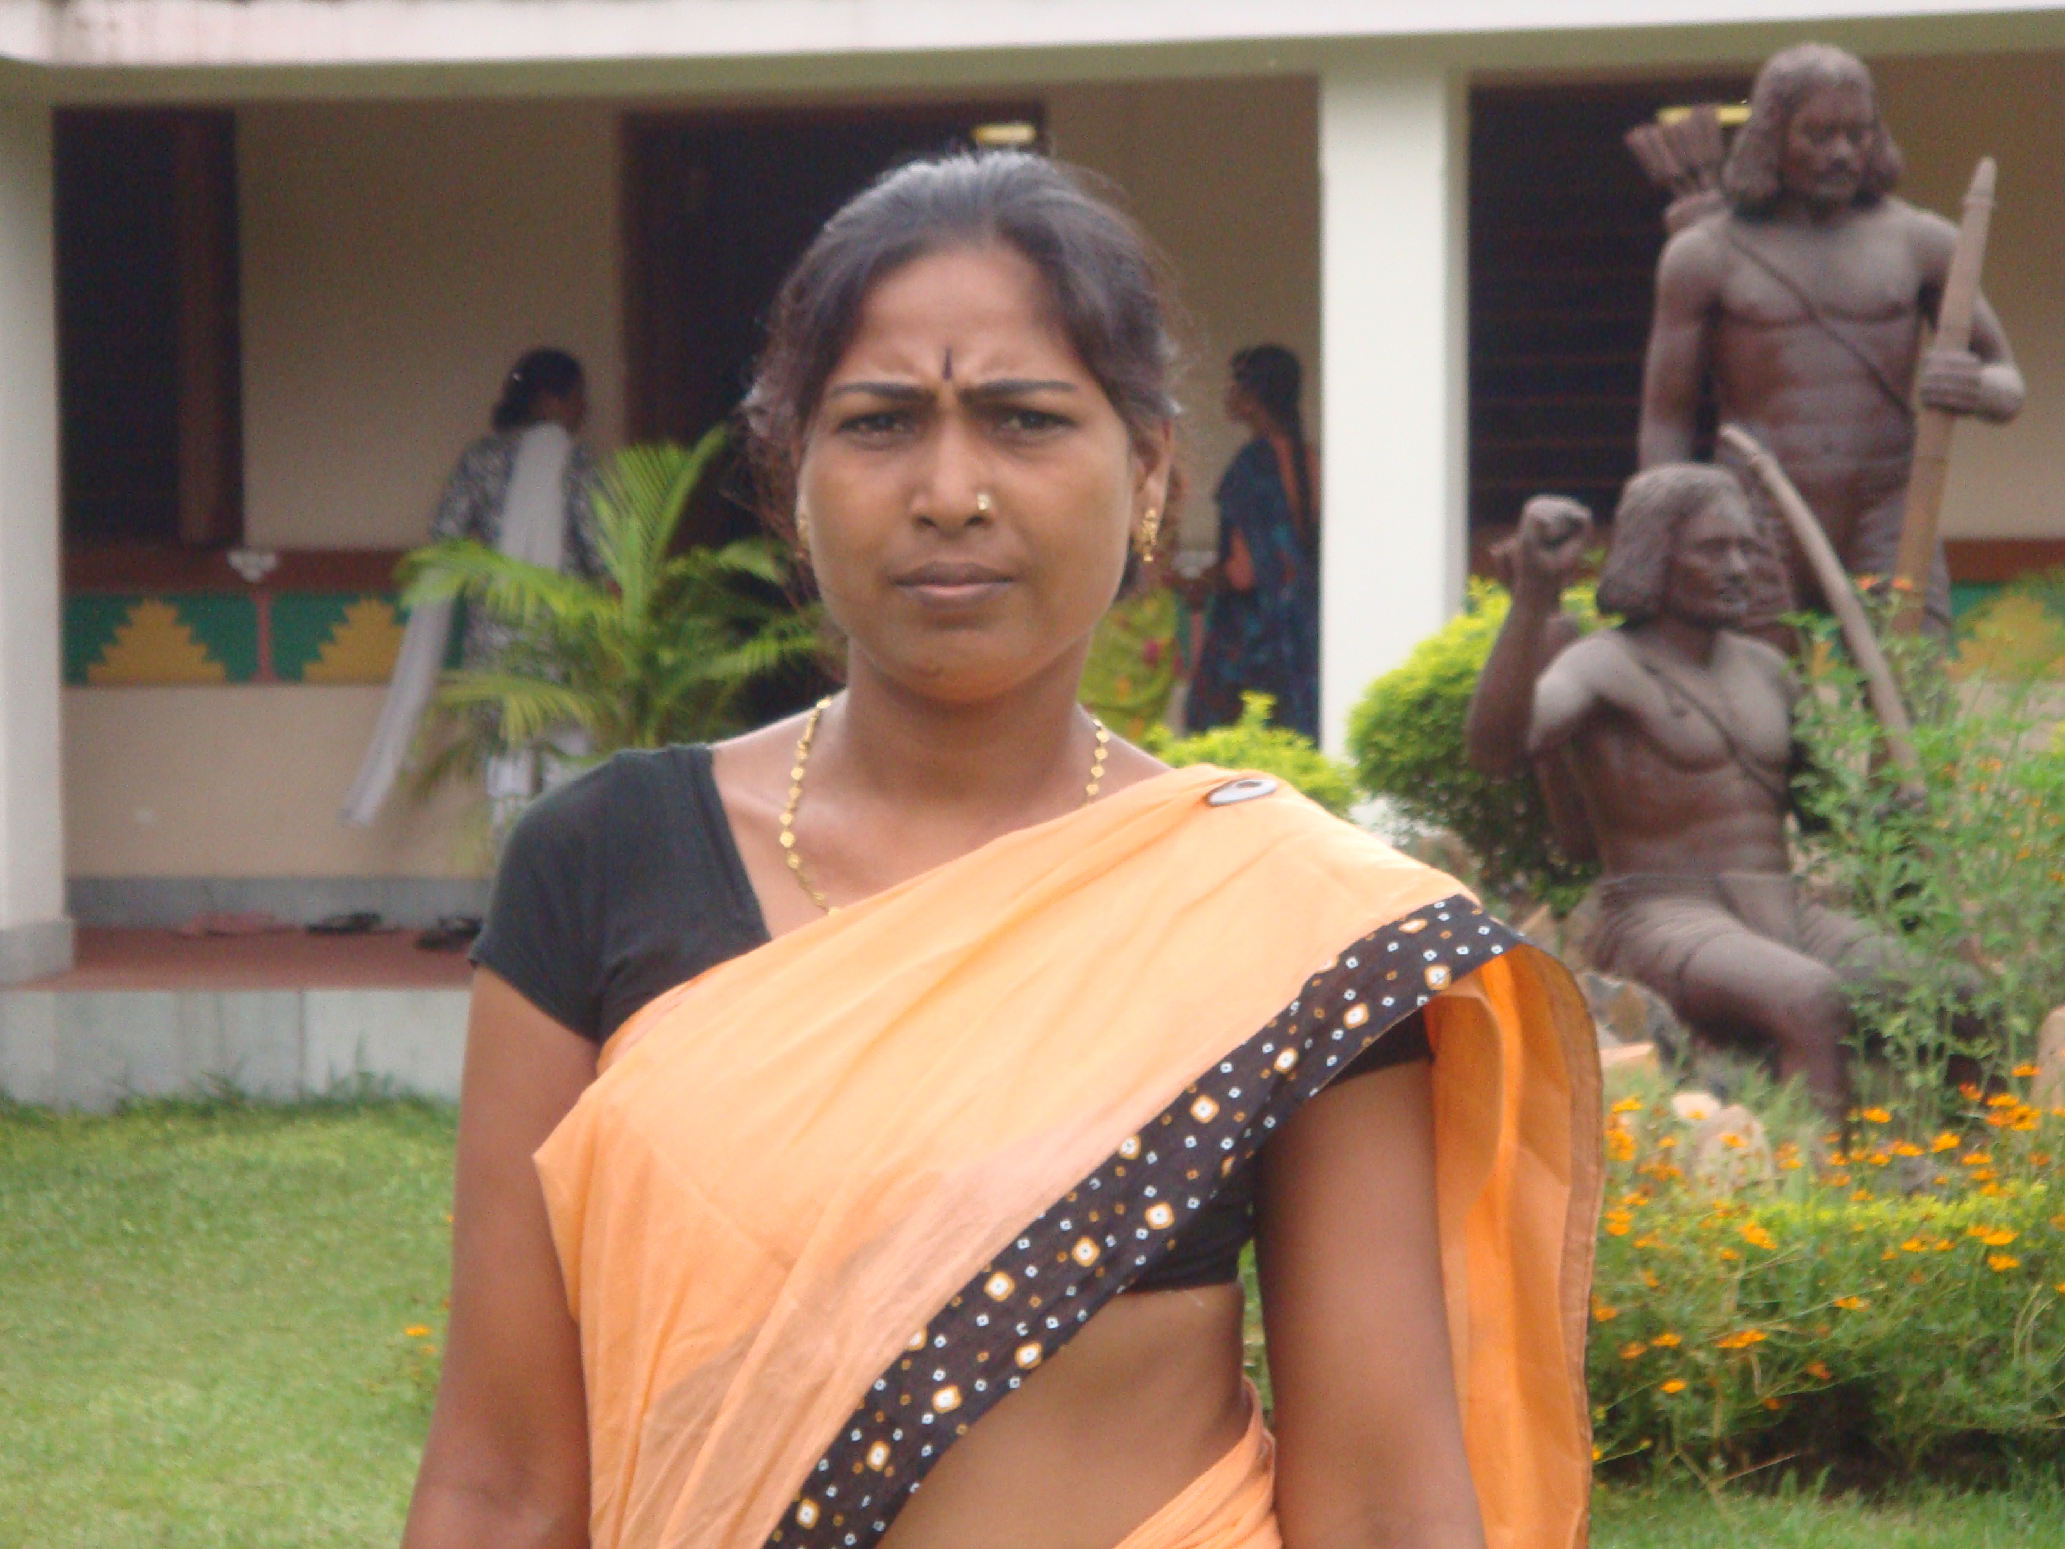

Mamta makes a new beginning

Mamta is a age of 35 year old women from Aurangabad, Bihar. She was married to Devendra Prashad of Chaibasa, West Singhbhum, Jharkhand.Mamta , like any other peaceful married life with two children. Suddenly life change for after herhusband,s demise in an accident. She was left at the crossroads when in laws rejected her and she got little support from her parents.

While she was dealing with her miseries of her life and her livelihood.She come in touch with Ekal Nari Sashakti Sangathan,Jharkhand and was motivated to join one of SHG group of ENSS and gradually picked up skill of embroidery and tailoring & start a small business. She took Bank Loan and started tailoring & stitching. She took up embroidery work, cutting, putting the Saree fall & Pico work. Her determination with the aspiration of ENSS bore fruits and her earning supported her children’s education. Today she is successful, self employed paying her bank loan and helping and motivating the other single women to sort out their problems.

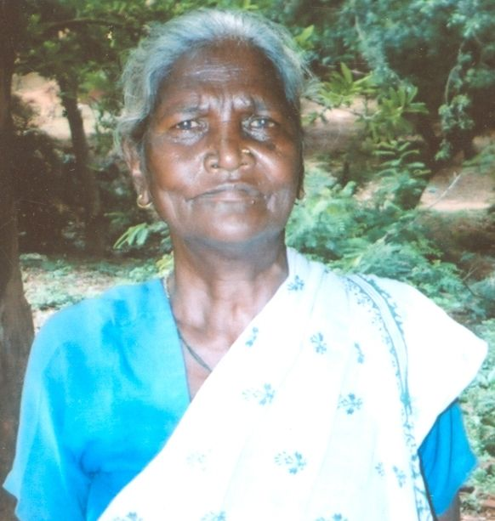 Name – Manki Hansda

Age – 65
Village – Purihasa
Singhbhum, Jharkhand

Manki Hansda is a Tribal lonely widow after her husband death 10 years back she earned her livelihood as a daily wage labour. She applied for old age pension at block development office. Wherein the Panchayat sewak took Rs.1500/- as bribe towards her work. But she was declined after repeated towards to the block office.

In the course of one of the meetings of Ekal Nari Sashakti Sangathan in Purihasa village, she
received its folder and came in touch. She was supported by ENSS and was directed to the block development office. The BDO office look into the matter and verified her earlier application and found that her old age pension had been actually sanction in the recode
dt 27 –11-2007. Then further squatness it was found that as some of Rs.13000/- was put in the account of concern Panchayat sewak who was dealing her matter.

She was apprised that her old age pension that was started actually misused by the Panchayat sewak. Further she opened a bank account with the help of ENSS. The block development office was regularly followed up with the effort of ENSS members & Manki. Today she is the proud recipient old age pension on a regular basis.

